**Semester 2 (Units 3 and 4) Examination, 2016**

**Question/Answer Booklet**

**MATHEMATICS METHODS**

**Section Two: Calculator-assumed**

Student Name/Number: ______________________________________________

Teacher Name: ______________________________________________

**Time allowed for this section**

Reading time before commencing work: ten minutes

Working time for this section: hundred minutes

**Materials required/recommended for this section**

**To be provided by the supervisor:** This Question/Answer Booklet

Formula Sheet (retained from Section One)

**To be provided by the candidate:**

Standard items: pens (blue/black preferred), pencils (including coloured), sharpener, correction fluid/tape, eraser, ruler, highlighters

Special items: drawing instruments, templates, notes on ____ unfolded sheets of A4 paper, and up to three calculators approved for use in the WACE examinations

**Important note to candidates**

No other items may be taken into the examination room. It is **your** responsibility to ensure that you do not have any unauthorised notes or other items of a non-personal nature in the examination room. If you have any unauthorised material with you, hand it to the supervisor **before** reading any further.

**Section Two: Calculator-assumed (104 Marks) Weighting 65%**

This section has **(thirteen)** **13** questions. Answer **all** questions. Write your answers in the spaces provided. Spare pages are included at the end of this booklet.

Suggested working time: **90 minutes**.

**Question 11 (3 marks)**

Consider the function . Using calculus techniques, determine the equation of the tangent at the point where , giving the exact value of all coefficients and constant terms.

**Question 12 (11 marks)**

(a) A bag contains one 50c coin, three 20c coins, seven 10c coins and k 5c coins.

(i) If one coin is selected at random, show that the probability of a 10c coin being

selected is 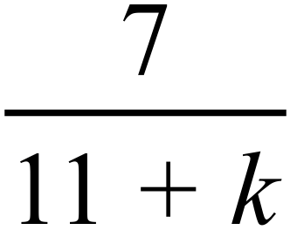 . (2 marks)

(ii) If the discrete random variable X is the amount in cents that can be obtained when one coin is selected at random, determine the value of k if .

(3 marks)

(b) A gas lighter ignites on any one trial with a probability of 0.4.

(i) The lighter will be tried until it ignites at least once. What is the minimum number of trials you should allow if you wish to be at least 99% sure it will ignite?

(3 marks)

(ii) The lighter has enough fuel to ignite nine times. Calculate the probability that the lighter will use the last of its fuel on the eleventh trial. (3 marks)

**Question 13 (8 marks)**

(a) A financeinvestment agencyadvertises that it compounds interestcontinuously and that it will double an initial investment in 12 years.

When interest is calculated in this way, the investment grows at the rate given by



where  represents the value of the investment after  years and  represents the annual interest rate. Determine the exact value of the annual interest rate. (3 marks)

(b) As a tornado moves, its speed S, in kilometres per hour, increases at the rate given by



where x is the distance the tornado has travelled in kilometres and  is a constant. If the speed of the wind is 65 km per hour before the tornado starts to move, show that the expression for the speed of the wind in terms of the distance the tornado has travelled is given by  (5 marks)

**Question 14 (9 marks)**

The diagram below shows the graph of the function  and a linear function  
, which is tangential to  at the point P.   
 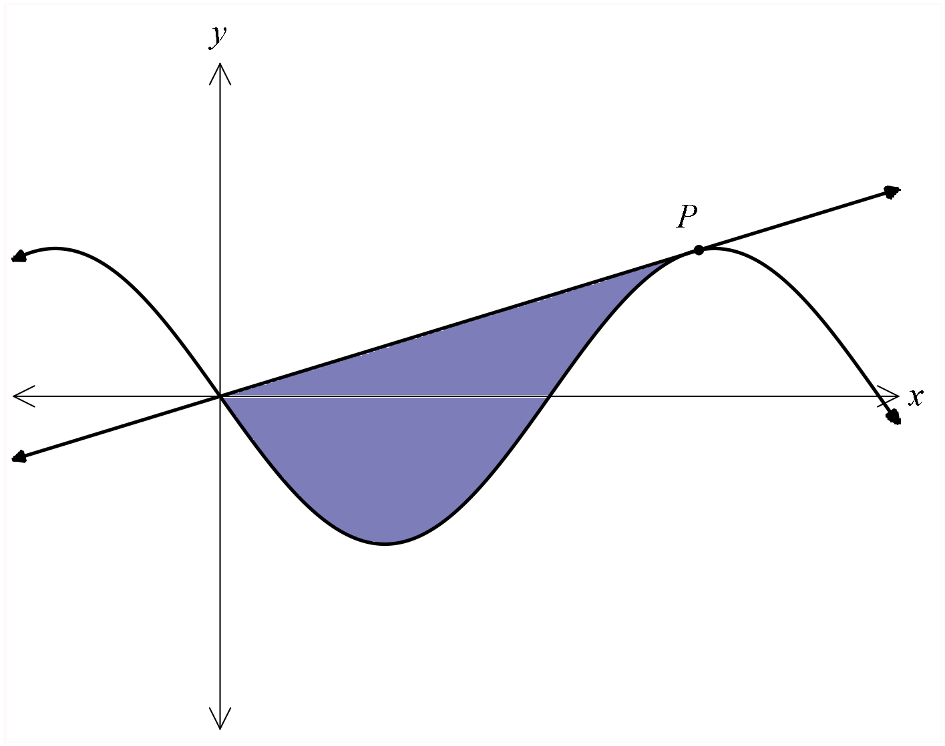

1. Given that  show that the coordinates of P are approximately .  
    (4 marks)

(b) Determine , the equation of the tangent, rounding the coefficient of *x* to one decimal place. (2 marks)

(c) Determine the area of the shaded region enclosed by  and . Give your answer to two decimal places. (3 marks)

**Question 15 (4 marks)**

(a) Consider the function , where . Determine . (1 mark)

(b) Hence determine an expression for . (1 mark)

(c) Using the result from part (b), determine an expression for . (2 marks)

**Question 16 (6 marks)**

A particle travels along a straight line with its acceleration at time *t* seconds given by

m/s2, where *k* is a constant. The particle has an initial velocity of 3 m/s. After 2 seconds the particle has a displacement of 19 m and after 3 seconds its displacement is 26 m. Calculate the distance travelled by the particle in the first three seconds.

**Question 17 (13 marks)**

The ABC bank, in a random sample of 625 of its customers, found that 450 of the sample used online banking to pay their bills.

(a) Calculate the sample proportion of these customers who had used online banking to pay their bills. (1 mark)

(b) Calculate the 99% confidence interval for the population proportion and interpret your answer. (3 marks)

(c) A second survey of ABC Bank customers is planned; however, it is decided that the 99% confidence interval should involve a maximum margin of error of 2%. Determine the sample size required for such a survey. (4 marks)

(d) If many samples of this size were taken how would you expect the sample proportions to be approximately distributed? Include the parameters of the distribution in your answer.  
 (3 marks)

(e) If eight surveys were taken and for each a 99% confidence interval for the population proportion was calculated, determine the probability that at least seven of the intervals included the true value of the population proportion. (2 marks)

**Question 18 (9 marks)**

(a) The loudness (in decibels) of a sound of intensity,*,*is defined to be



where  is the minimum intensity of sound that can be detected by the human ear.

(i) The loudness of the sound of a vacuum cleaner is 70 decibels. Determine the intensity of this sound in terms of . (1 mark)

(ii) The intensity of the sound of an electric drill is . How many times is the intensity of the sound of the electric drill greater than the intensity of the sound of a vacuum cleaner. (2 marks)

(iii) Determine the loudness (in decibels) of the sound of the electric drill in part (ii).

(1mark)

(b) A particle is in rectilinear motion and its velocity,, at any time *t* seconds is given by



(i) Determine an expression for, the acceleration of the particle. (1 mark)

(ii) What is the velocity and the acceleration of the particle when ? (2 marks)

(iii) What feature of the velocity is indicated by the value of the acceleration when  (1 mark)

(iv) During a particular second, the acceleration increases from –1.8  to 1.5 . Describe the velocity of the particle during this second. (1 mark)

**Question 19 (10 marks)**

The continuous random variable X has probability density function 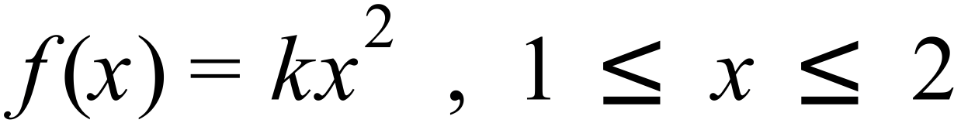 .

(a) Determine the value of the constant k. (2 marks)

(b) Determine the standard deviation of X. (3 marks)

(c) Determine the cumulative distribution  . (3 marks)

(d) Given that the median, m, divides  into two equal areas, determine the value of m .

(2 marks)

**Question 20 (5 marks)**

(a) The number of students in each of the years 7 to 9 at a Perth school is given in the table below:

|  |  |  |  |
| --- | --- | --- | --- |
| Year | 7 | 8 | 9 |
| Number of students | 305 | 381 | 346 |

A stratified sample of 75 students is to be selected from the year 7 to 9 students they can complete a survey. How many of each year group should be in the sample if it is to reflect the proportions of the whole school population? (2 marks)

(b) A unbiased six sided die is rolled and the number on the uppermost face is recorded as the random variable *X*.

(i) What is the distribution of *X*? (1 mark)

(ii) What is the mean of the distribution (1 mark)

The graph below shows the distribution of a sample of 25 numbers generated when an unbiased six sided die was rolled.

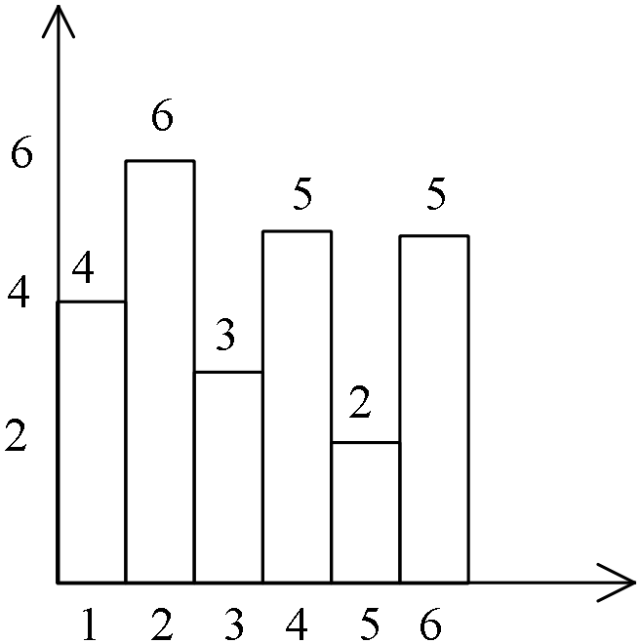

(iii) If the sample size was 1000 describe the changes you would expect to see in the graph. (1 mark)

**Question 21 (7 marks)**

The company Macom manufactures machine components. Random samples of machine components made by Macom were taken and the proportion of defective components in each sample was determined. The number in each sample was also noted. Consider the results of eight such samples tabled below:

|  |  |  |  |  |  |  |  |  |
| --- | --- | --- | --- | --- | --- | --- | --- | --- |
| Sample | 1 | 2 | 3 | 4 | 5 | 6 | 7 | 8 |
| Number in sample | 122 | 72 | 450 | 158 | 280 | 150 | 205 | 310 |
| Sample proportion of defective components  (rounded to 4 d.p.) | 0.0246 | 0.0139 | 0.0222 | 0.0253 | 0.0250 | 0.0133 | 0.0244 | 0.0226 |

(a) Explain which single sample is likely to give the best estimate of the population proportion of defective components. (1 mark)

(b) The owner of Macom reviews the above data and estimates the population proportion of defective components by calculating the mean of the sample proportions. Determine her estimate and explain why this is not a good idea. (2marks)

(c) An analyst working for Macom uses the above data to make the best possible estimate of the proportion of defective components. Determine this estimate and explain why it is the best possible from the data available. (4 marks)

**Question 22 (8 marks)**

A machine is producing bolts whose lengths are normally distributed with a mean of

6.50 cm. An upper tolerance limit of 6.54 cm has been adopted and, when the machine is correctly set, 1 in 20 bolts is rejected as exceeding this limit. On a certain day, it is found that 1 in 15 bolts is rejected for exceeding this limit.

(a) Assuming that the mean has not changed but that the production has become more variable, estimate the new standard deviation (3 marks)

(b) Assuming that the standard deviation has not changed but that the mean has moved, estimate the new mean. (4 marks)

(c) If 1000 bolts are produced in a shift, how many of them may be expected to have lengths in the range 6.48 to 6.53 cm if the machine is set as in part (a)? (1 mark)

**Question 23 (11 marks)**

Suppose that the quantity q of some product that the public would like to buy if the price were x is given by 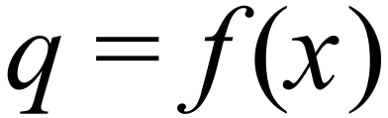. The elasticity of demand E is defined by

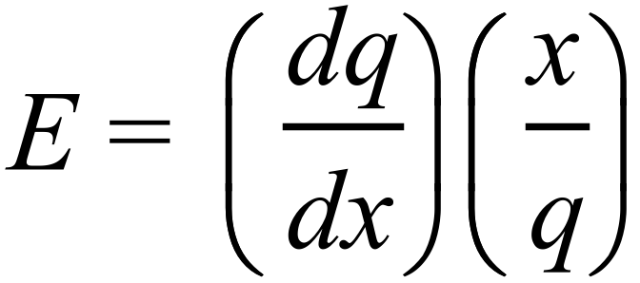

(a) Show that 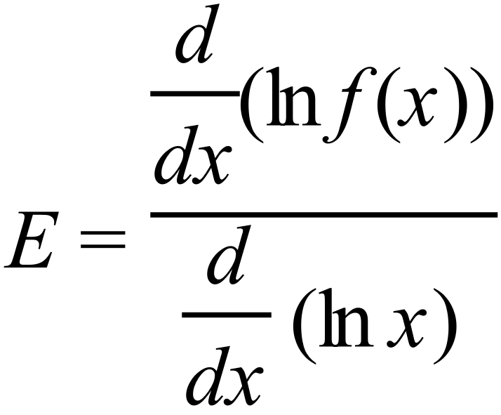 , justifying your answer. (3 marks)

(b) Show that, if  then 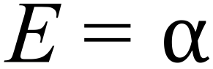 (2 marks)

(c) If 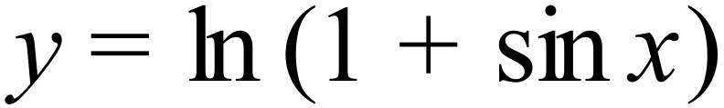, prove that 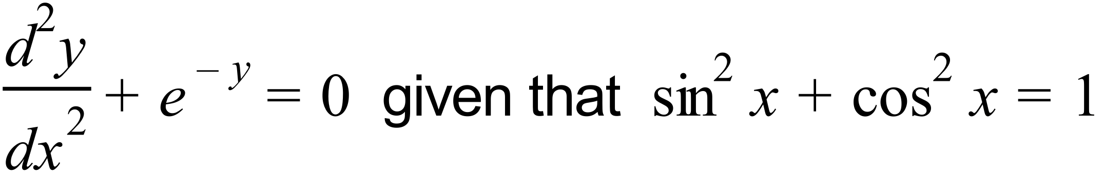

(4 marks)

(d) What can be deduced from 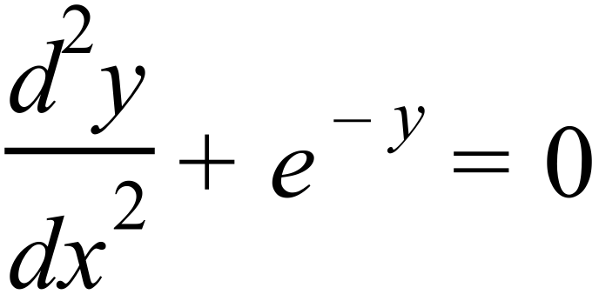 about the stationary points of y? (2 marks)

**End of questions**